Please return completed application to:  roundtop@arborantiques.com | The Arbors Round Top  Show Application

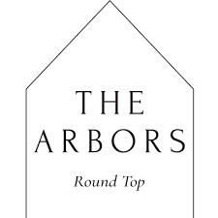
New Dealer Application

Applicant Information
Full Name: |  |  |  | Date:
 | Last | First | M.I.

Address:
 | Street Address | Apartment/Unit #

 | City | State | ZIP Code

Phone: |  | Email

Is this your first time showing in Round Top? | YES | NO

Have you shown in other markets before? | YES | NO

If yes, what shows have you done?

Business Information
Business Name: |  | Website:

What category is your merchandise?

Art Home Décor Furniture Rugs Fashion Other:

Please describe your product here:

Social Media Handles:

Instagram: Facebook:

Other:

Did someone refer you to The Arbors at Round Top?
Full Name: |  | Relationship:
Company: |  | Phone:

